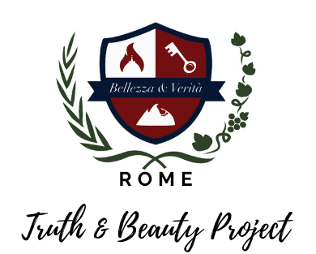

**Truth & Beauty Project Scholarships**

**More information at: www.truthandbeautyproject.com**

The Scholarship Fund exists to make the Truth & Beauty experience possible for young adults in financial difficulty.

**Note that our scholarships can be applied toward program fees and do not include airfare.** We strongly encourage you to fundraise locally for your airfare and any remaining expenses.

Financial assistance is given on the basis of need.

1. If you intend to fundraise for this experience, what are your ideas for how to do it?
2. Based on your need, what level of assistance would you like to apply for?
3. Please describe your financial situation:

**Email your completed form to bellezzaeveritaproject@gmail.com**